**Project 6**

*Real-Time and Embedded Systems*

Chaithanya Gadiyam (cg8327@rit.edu)

Michael Moffitt (mjm6398@rit.edu)

# Area of Focus

The project work was split into two major tasks namely design and implementation of qnx code which calculates the voltage of analog signal; design and implementation of freescale code which controls to servo motor. However, both of us worked on integration and testing.

# 

# Design and Analysis

As the project objective suggests, the project includes a QNX Neutrino program which runs on QNX purple box and Freescale program which runs on Freescale board. The QNX program implements calculation of voltage of analog signal using analog to digital converter on purple box and scales the digital voltage to communicate with Freescale board. The Freescale program includes control of servo motor based on digital voltage Freescale board receives from purple box.

Analog to digital converter on purple box is configured for analog input channel 4 as input channel, using ADC channel register present in shared memory. Gain is set to 1 using ADC gain register present in shared memory. The ADC conversion process is implemented as an infinite loop. The program checks for wait bit in ADC status register to ensure the previous ADC conversion is complete and is ready for a new conversion. The conversion is started by setting the start bit in command register. Again the status register is used to wait on conversion. Once the conversion is done, the program reads 16 bit digital voltage from LSB and MSB data registers present in shared memory. If the read value is a positive voltage, the 15 bit value is scaled to a 5 bit value and communicated with freescale board through port A of I/O ports on purple box. The clock bit is inverted every 20 ms, since the response time of servo motor to move from one extreme position to another is 20 ms. If the value read is an out of range voltage the program sends a magic number to freescale board to indicate out of range voltage and it also prints an error message on the console.

The Freescale program basically reads the 5 bit value sent from purple box when clock goes high and uses the digital voltage to control the servo position. User can control the operation of servo motor by using push button (PB1) on Frescale board, i.e to start and stop the servo operation. This program uses PWM module on freescale board to generate a pulse with pulse width proportional to the 5-bit value received from purple box. If the received 5 bit value is a magic number, it indicates an out of range voltage and displays an error message on console.

# Block Diagram

Analog signal

5 bit voltage and clock signal

Servo motor

PWM module

Freescale program:

Receives the 5 bit value on clock high and generates pulse of whose pulse with is proportional to the 5 bit value, to control the servo motor

Freescale board

Purple box

QNX program:

Reads the 16 bit value from ADC and scales it to 5 bit value, sends it to freescale board through I/O port A

ADC

# Testing and Outputs

To ensure a smooth development process and debug the errors quickly, the approach of performing component level testing before integration can be employed. The test plan can be divided into three phases, namely testing of QNX program, testing of Freescale program and testing of the integrated system.

The QNX program alone has been tested by connecting the signal generator output to the ADC input channel and by the observation of 5 bit digital voltage and clock signal displayed on the IDE console. The program has been tested on different kinds of input signals such as square wave, sine wave, triangular value and observed desired output on console.

The Freescale program alone can be tested by implementation of a timer which periodically generates a random 5 bit voltage in the range of 0-5 volts, using which the servo motors are controlled. The value generated periodically by the timer is displayed on the console to correlate with the servo position to ensure correct operation of freescale program.

After ensuring correct operation of QNX program and freescale program individually, the integrated system can tested to check the communication link between purple box and freescale board and also functionality of the system on a whole. This can be achieved by connecting a signal generator output to the ADC input channel and observing the corresponding position on servo motor. Fault conditions like out of range voltage or communication failure have been tested by giving negative input voltage and by disconnecting the communication link between the two platforms. In such fault conditions the console on both platforms display an error message. The operation of bush button is also tested, which is used to start and stop the servo motor operation.

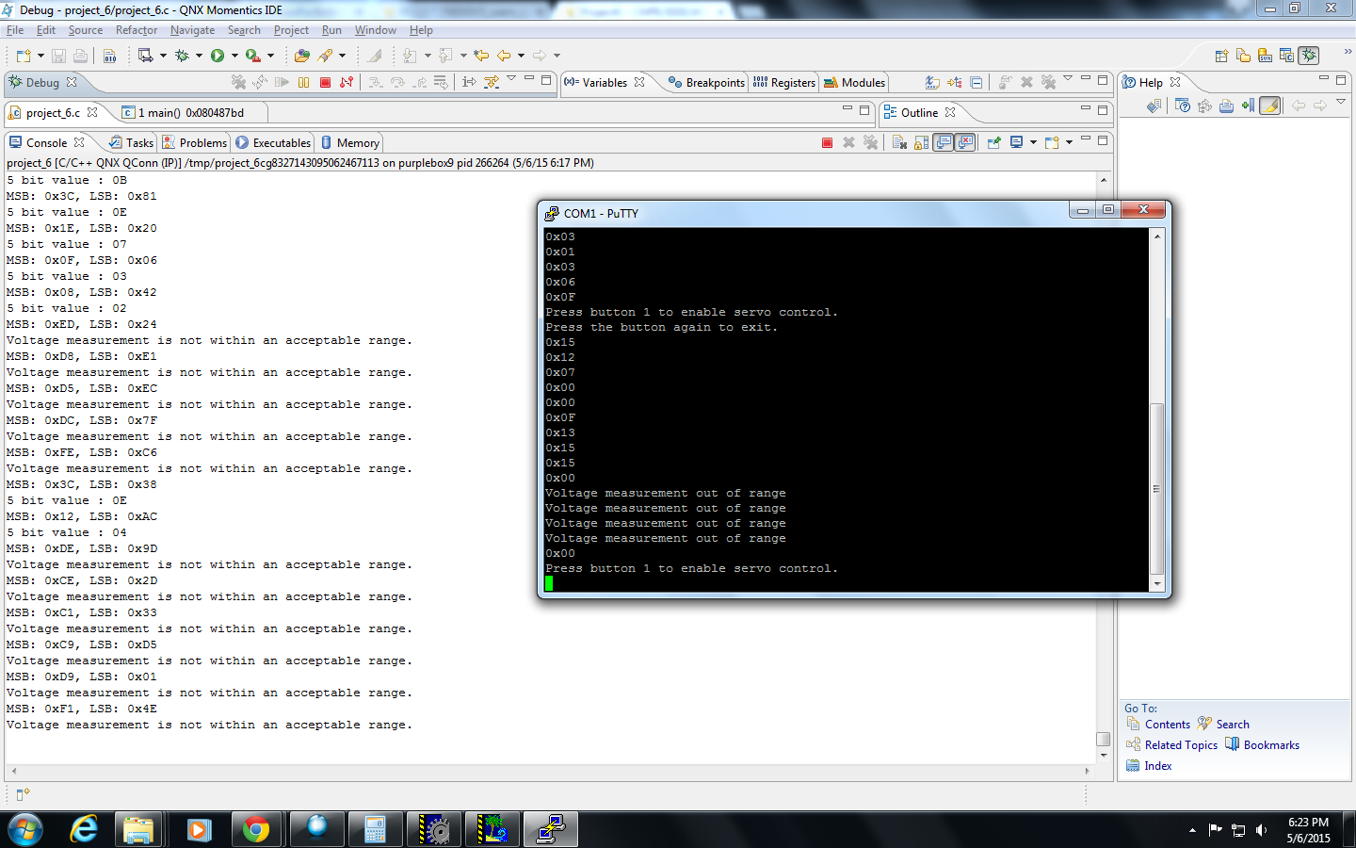

# Lessons Learnt

Gained knowledge about configuration of Analog to digital converter on purple box. Also learnt about implementing a system which involves communication between two different platforms such as purple box and freescale board.